
Tertiary Infotech Academy Pte Ltd
UEN: 201200696W
LEARNER GUIDE
For
Creating Professional Graphics with Adobe Illustrator
TGS Ref No: TGS-2021003160
Conducted by
Tertiary Infotech Academy Pte Ltd
UEN: 201200696W
Version 11

DOCUMENT VERSION CONTROL RECORD
Version Number | Effective Date of Release | Summary of Included Changes | Author
10.0 | Legacy release | Previous trainer slide source and Illustrator exercise-file set. | Tertiary Infotech Academy
11 | 21 August 2026 | Rebuilt aligned guide with ten self-contained Illustrator/vector labs, current official-source references, detailed procedures, evidence and acceptance criteria. | Dr Alfred Ang

TABLE OF CONTENTS
Purpose and Use
Learning Outcomes
TSC Alignment
Core Professional Workflow
Topic 1 — Basic Digital Graphics Design with Illustrator
Topic 2 — Improve Digital Graphics Design with Illustrator
Topic 3 — Evaluate Graphics Design with Illustrator
Intellectual Property and Responsible AI
Source Register

Purpose and Use
This Learner Guide carries the detailed procedures intentionally omitted from the visual course slides. Work from the supplied Illustrator/vector files, preserve originals, keep the AI master editable, and verify every export.

Learning Outcomes
- LO1: Apply basic Illustrator techniques for digital graphics.
- LO2: Improve Illustrator techniques through experimentation.
- LO3: Evaluate and output digital graphics.

TSC Alignment
Code | Knowledge / Ability
K1 | Techniques and materials to achieve different effects in digital imaging
K2 | Range of materials, tools and equipment used in digital imaging
K3 | Workspace requirements for digital imaging
K4 | Theoretical contexts for digital imaging
K5 | Principles of design and their application to digital image work
K6 | Intellectual property considerations
A1 | Explore ideas and techniques for digital imagery in consultation with key stakeholders
A2 | Improve techniques to produce digital images through practice and experimentation
A3 | Evaluate the capabilities of digital imaging techniques through practice and adaptation
A4 | Discuss the process for producing digital imaging with others

Core Professional Workflow
1. Clarify purpose, audience, output channel and constraints.
2. Verify source quality, ownership, licence, consent and permitted use.
3. Set artboard dimensions, colour mode, bleed, transparency and required formats.
4. Build with economical paths, live shapes, named layers, groups, swatches and reusable appearances.
5. Experiment by changing one factor at a time and retaining a baseline.
6. Evaluate hierarchy, geometry, consistency, technical output and rights evidence.
7. Export, reopen and verify every derivative; retain the editable AI master and evidence.

Topic 1 — Basic Digital Graphics Design with Illustrator
Vector foundations · workspace · selection · shapes · colour · strokes · layers · transforms
Alignment: LO1 · A1 · K1 · K2

Key Concepts
Vector model: Paths, anchors, fills and strokes describe artwork independently of output resolution.
Workspace: Tools, Properties, Control, Layers and Artboards panels support a visible, repeatable workflow.
Selection: Selection acts on objects; Direct Selection acts on anchors and segments.
Colour: RGB, CMYK and HSB answer different display, print and colour-description needs.
Structure: Layers, groups, naming and stacking order keep complex artwork understandable.

Lab 01 — Workspace, Artboards and Selection
Scenario: Prepare a starter document for a small icon team so another designer can navigate it confidently.
Objective: Set up a reliable vector workspace and distinguish object, group and anchor-level selection.
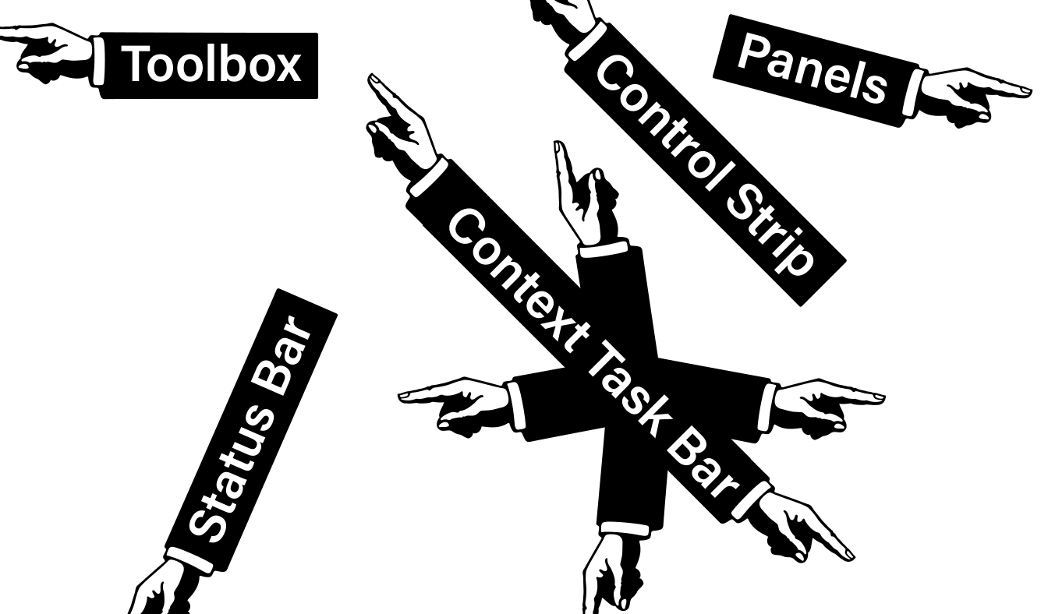

Detailed Procedure
1. Open workspace.ai and save a working copy named Lab01-Workspace-Selection.ai.
2. Reset or choose a suitable workspace; display Properties, Layers and Artboards panels.
3. Name the first artboard and add a second output artboard with a different size.
4. Use Selection, Direct Selection and Group Selection on supplied artwork; record what each targets.
5. Enter and exit Isolation mode; lock one approved object and verify it cannot be changed.
6. Save the editable AI file and export a labelled PDF or PNG evidence board showing both artboards.

Evidence to Retain
Lab01-Workspace-Selection.ai plus an exported evidence board and short comparison of the three selection scopes.

Acceptance Criteria
- Two correctly named artboards are present.
- Only intended objects or anchors changed.
- Layers and groups have meaningful names.
- The exported evidence board shows the final state clearly.
Lab folder: labs/lab-01-workspace-selection/

Lab 02 — Shapes, Lines and Transform Systems
Scenario: Create three related wayfinding icons that must remain consistent across print and screen sizes.
Objective: Construct a precise icon set from live shapes and numeric transforms.
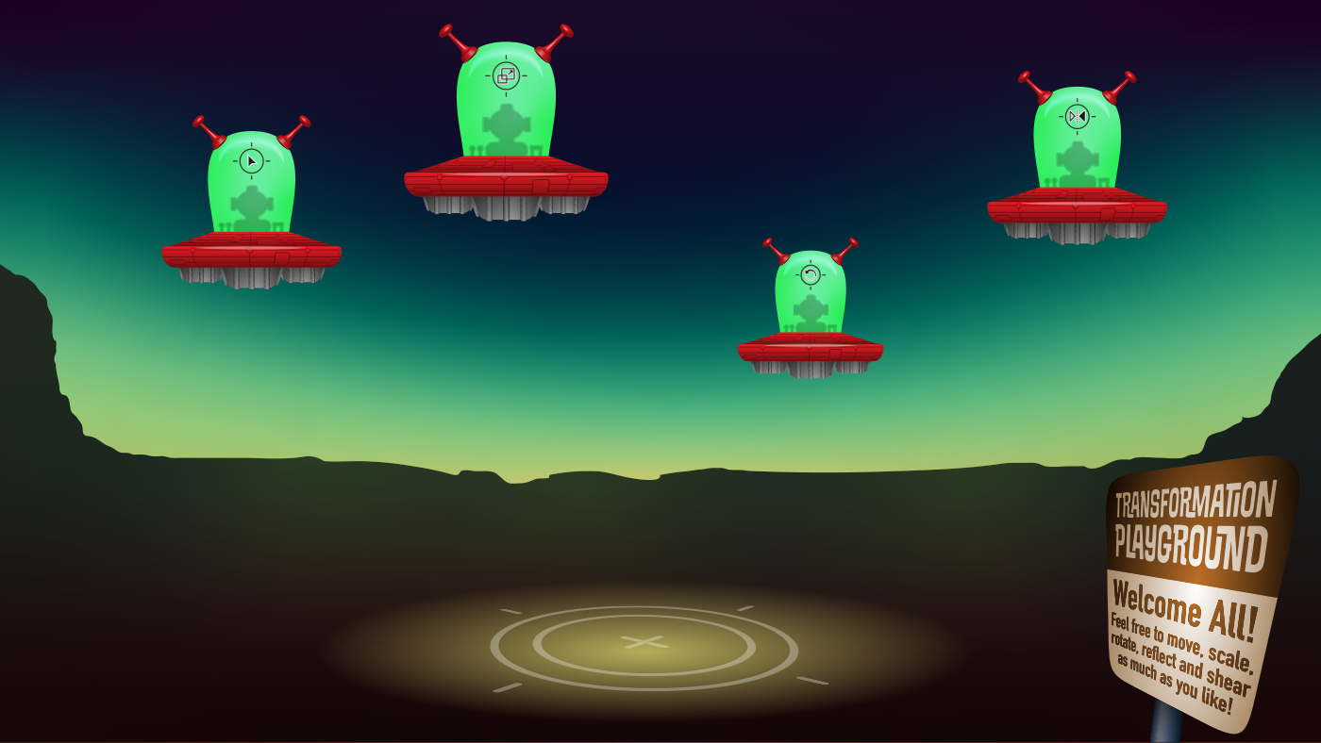

Detailed Procedure
1. Open shapesLines.ai and save Lab02-Shape-System.ai.
2. Build three icons with rectangles, ellipses, polygons, stars and line segments.
3. Use numeric position, size and rotation values for at least one repeated element.
4. Align and distribute the icons on a shared spacing system.
5. Duplicate one icon and use Transform Each or a reflected copy to create a controlled variant.
6. Inspect at small and large size, correct inconsistent proportions and export SVG and PDF proofs.

Evidence to Retain
Editable AI master, three icon variants, SVG exports and a one-page PDF comparison.

Acceptance Criteria
- Live shapes remain editable where practical.
- Spacing and alignment are consistent.
- Strokes scale intentionally.
- SVG and PDF exports match the master.
Lab folder: labs/lab-02-shapes-transform/

Lab 03 — Colour Systems, Swatches and Strokes
Scenario: Adapt one campaign mark for RGB social delivery and a CMYK print proof without losing consistency.
Objective: Create screen and print colour variants with a controlled stroke language.
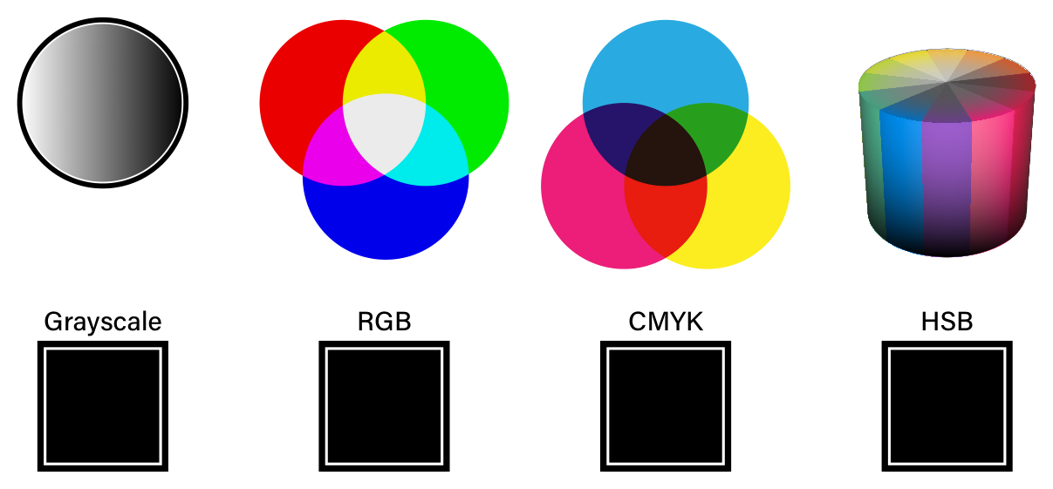

Detailed Procedure
1. Open color.ai and save Lab03-Colour-Strokes.ai.
2. Identify the document colour mode and create named process swatches for the brief.
3. Create at least one global swatch and demonstrate a tint or global update.
4. Apply a consistent stroke system using weight, cap, join and dash settings.
5. Create a second output variant in the other colour mode using a separate document or copy.
6. Export screen and print proofs and record the swatch and stroke decisions.

Evidence to Retain
Two colour-mode proofs, editable AI files and a decision note covering swatches and stroke behaviour.

Acceptance Criteria
- Colour modes match the named outputs.
- Repeated colours use named swatches.
- Caps, joins and dashes are intentional.
- Exports show no unexpected colour or stroke change.
Lab folder: labs/lab-03-colour-strokes/

Lab 04 — Layers, Groups and Alignment
Scenario: Prepare an inherited artwork file for team handoff and rapid variant production.
Objective: Reorganise a complex document so stacking, grouping and alignment are clear and auditable.
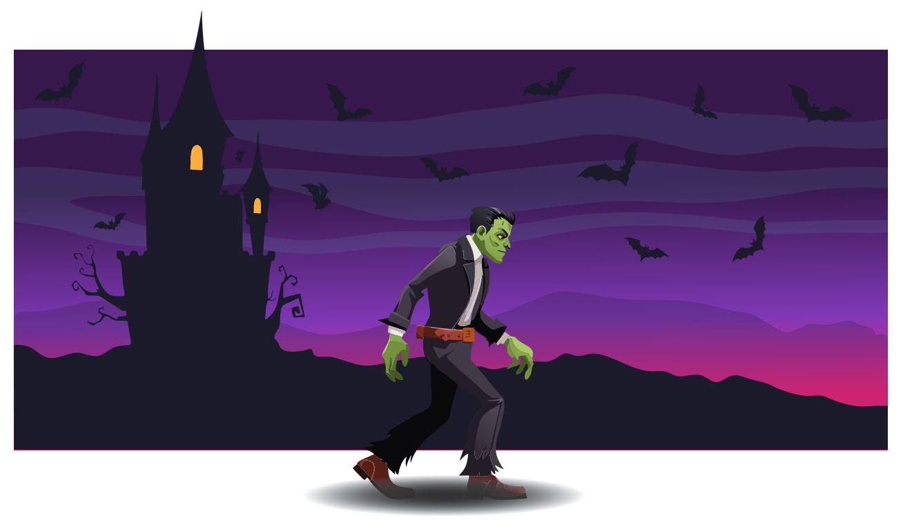

Detailed Procedure
1. Open layers.ai and save Lab04-Layer-Handoff.ai.
2. Audit the current hierarchy and rename layers or groups by function.
3. Move objects into logical groups without changing the visible result.
4. Use align and distribute controls to correct one inconsistent component group.
5. Create two visibility variants using the same structured master.
6. Ask a peer to locate and edit a named component, then record any navigation issue and revise the structure.

Evidence to Retain
Structured AI master, two variants and a brief peer-navigation record.

Acceptance Criteria
- No generic or ambiguous layer names remain.
- Stacking order matches the intended design.
- Alignment is visibly consistent.
- A peer can locate the requested component quickly.
Lab folder: labs/lab-04-layers-groups-alignment/

Topic 2 — Improve Digital Graphics Design with Illustrator
Construction · guides · pen control · gradients · patterns · symbols · appearance · type
Alignment: LO2 · A2 · K3 · K4

Key Concepts
Construction: Pathfinder, Shape Builder and compound paths turn simple geometry into editable forms.
Precision: Guides, grids, Smart Guides and numeric transforms control alignment and repeatability.
Experimentation: Duplicate a baseline, vary one factor, compare consistently and retain the rationale.
Theoretical context: Constructivist and Swiss-style principles provide different rationales for geometry, hierarchy, grids and type.
Appearance: Multiple fills, strokes, transparency and effects change presentation without redrawing the path.
Typography: Type choice, hierarchy, spacing and path behaviour must support audience and message.

Lab 05 — Pathfinder, Shape Builder and Masks
Scenario: Develop a product badge that combines overlapping geometry, a clipped image treatment and a soft transparency option.
Objective: Compare construction methods and select the most editable result for a badge system.
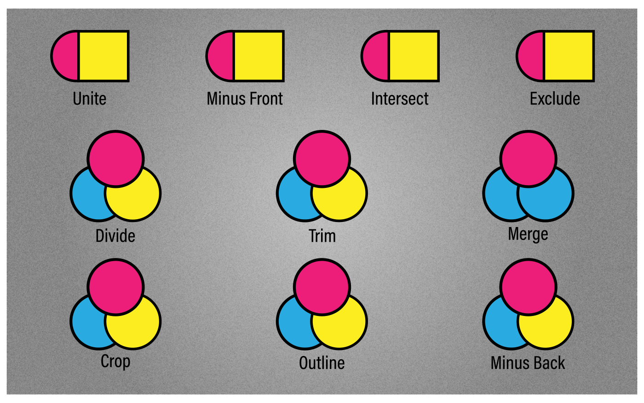

Detailed Procedure
1. Open pathfinders.ai and save Lab05-Construction-Masks.ai.
2. Create the same core badge with Pathfinder and Shape Builder on separate layers.
3. Compare path count, editability and stray geometry; retain the stronger construction.
4. Create a compound path or shape that includes a deliberate counter or hole.
5. Use clipping.ai to build an image-in-shape treatment and a separate opacity-mask variation.
6. Inspect boundaries at high zoom, remove stray paths and document why the chosen method fits the brief.

Evidence to Retain
Editable comparison layers, final badge, clipping and opacity-mask variations and method rationale.

Acceptance Criteria
- The final badge has clean, intentional geometry.
- The chosen construction remains editable.
- Masks preserve source content.
- No stray or unintended paths remain.
Lab folder: labs/lab-05-construction-masks/

Lab 06 — Pen, Curvature, Pencil and Brushes
Scenario: Produce a mascot mark with a precise silhouette and an expressive supporting stroke.
Objective: Create controlled and expressive paths while keeping anchor economy and brush behaviour visible.


Detailed Procedure
1. Open PenTools.ai and save Lab06-Path-Control.ai.
2. Trace one straight and curved form with the Pen tool using the fewest practical anchors.
3. Create a Curvature-tool alternative and compare smooth and corner-point handling.
4. Use Pencil settings to draw an expressive supporting path and smooth only where required.
5. Apply or create an appropriate brush; test scale, direction and colourisation behaviour.
6. Overlay the alternatives, inspect for kinks or noise and export the selected mark with an anchor-count note.

Evidence to Retain
AI master with Pen, Curvature and Pencil alternatives plus exported selected mark.

Acceptance Criteria
- Curves are smooth and economical.
- Corner points appear only where intended.
- Brush direction and scaling are correct.
- The selected method is justified by visible evidence.
Lab folder: labs/lab-06-pen-pencil-brush/

Lab 07 — Gradients, Patterns and Symbols
Scenario: Create a packaging surface system with a gradient backdrop, seamless motif and reusable icons.
Objective: Build reusable colour and repetition systems, then improve one option through controlled experimentation.


Detailed Procedure
1. Open gradients.ai and save Lab07-Reusable-Systems.ai.
2. Create linear, radial and freeform gradient variants while holding the base shape constant.
3. Compare the variants against a stated focal-hierarchy criterion and choose one.
4. Build a seamless pattern tile; test object-only, pattern-only and combined transforms.
5. Create a symbol from an icon and place several instances with intentional overrides where supported.
6. Apply the chosen systems to a packaging panel, export a proof and record the experiment that improved it.

Evidence to Retain
Editable AI master, gradient tests, seamless pattern proof, symbol instances and final packaging panel.

Acceptance Criteria
- The selected gradient supports the intended hierarchy.
- The pattern has no visible seams.
- Symbol instances are consistent.
- The improvement decision is recorded and evidenced.
Lab folder: labs/lab-07-gradients-patterns-symbols/

Lab 08 — Appearance, Graphic Styles and Typography
Scenario: Develop two headline treatments for stakeholder review and recommend the one that best fits a professional event campaign.
Objective: Design a typographic poster with live type and reusable appearance treatments.
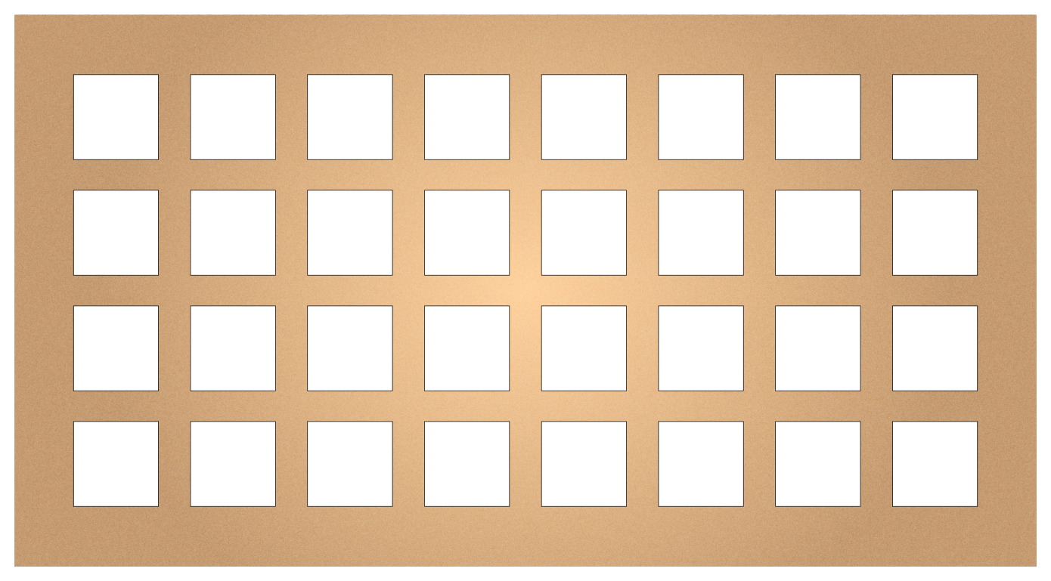

Detailed Procedure
1. Open appText.ai and save Lab08-Type-Appearance.ai.
2. Create point type for the headline and area type for supporting copy; correct any overset text.
3. Set hierarchy with size, weight, leading, tracking, alignment and spacing.
4. Build Treatment A with multiple fills or strokes in the Appearance panel and save a Graphic Style.
5. Build Treatment B with restrained transparency or a live effect while retaining editable type.
6. Present both options, record stakeholder feedback, revise one treatment and export the final poster proof.

Evidence to Retain
Live-type AI master, two treatment proofs, feedback note and revised final poster.

Acceptance Criteria
- No overset or missing-font warning remains.
- Hierarchy is clear at delivery size.
- Appearance attributes remain editable.
- The final choice reflects recorded stakeholder feedback.
Lab folder: labs/lab-08-appearance-typography/

Topic 3 — Evaluate Graphics Design with Illustrator
Placed imagery · Image Trace · artboards · evaluation · export · package · IP · peer review
Alignment: LO3 · A3 · A4 · K5 · K6

Key Concepts
Evaluation: Judge hierarchy, balance, contrast, alignment, proximity, consistency and technical fitness.
Output: Choose AI, PDF, SVG, PNG or JPEG according to editability, scale, transparency and channel.
Image Trace: Convert suitable raster sources to paths, then inspect path count, corners, noise and fidelity.
Handoff: Package or collect dependencies, preserve an editable master and verify every exported derivative.
Rights: Record ownership, licence, consent, permitted modification, attribution and intended use.

Lab 09 — Image Trace, Artboards and Export
Scenario: Prepare a small icon or logo asset family for web, presentation and print use.
Objective: Convert suitable raster artwork, clean the vector result and deliver a verified multi-artboard asset set.
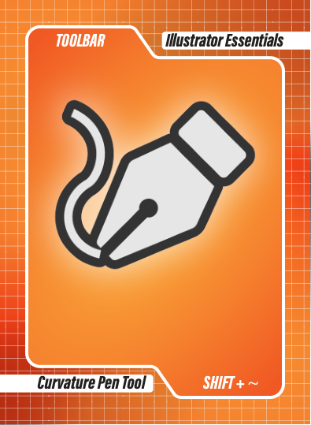

Detailed Procedure
1. Open adScreen.ai and save Lab09-Trace-Export.ai.
2. Identify a suitable raster element and compare at least two Image Trace presets or settings.
3. Expand the selected trace, remove noise and stray paths and simplify only where fidelity is preserved.
4. Create named artboards for web icon, presentation graphic and print mark.
5. Use Export for Screens or Asset Export to produce SVG, PNG and PDF derivatives with clear suffixes.
6. Reopen every derivative, verify size, transparency and colour and record the selected trace settings and path-count trade-off.

Evidence to Retain
Clean AI master, named artboards, SVG, PNG and PDF derivatives and an export verification record.

Acceptance Criteria
- The trace has acceptable fidelity and manageable path complexity.
- Artboards are correctly named and sized.
- All derivatives reopen successfully.
- Transparency and colour behaviour match the brief.
Lab folder: labs/lab-09-image-trace-artboards-export/

Lab 10 — Brand System Capstone, Handoff and Peer Review
Scenario: Create a launch kit containing a mark, icon family, social tile and packaging panel for a fictional sustainable retail brand.
Objective: Integrate the course workflow into a coherent vector brand kit, evaluate it and prepare a rights-aware handoff.
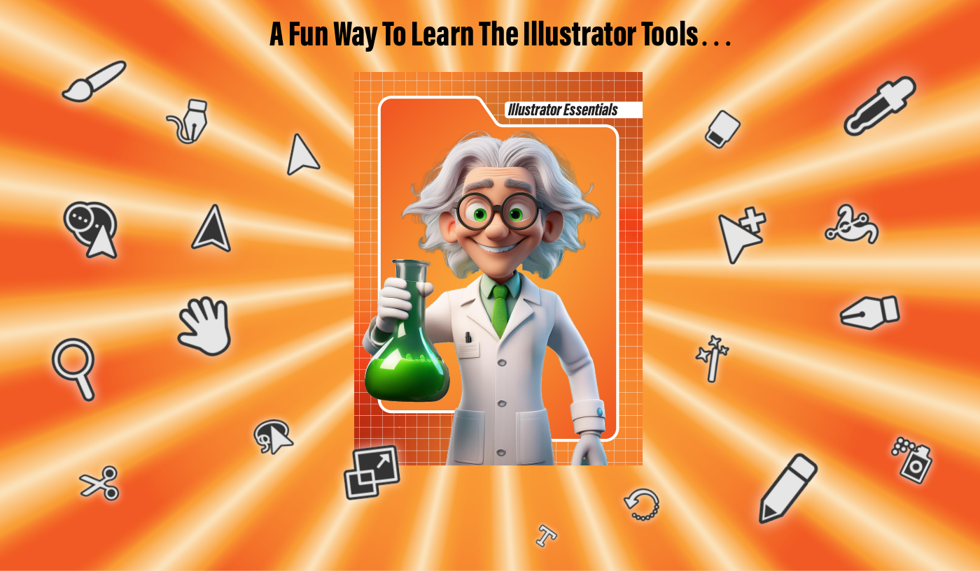

Detailed Procedure
1. Open cardBG.ai and save Lab10-Brand-System.ai; define audience, message, channels and acceptance criteria.
2. Create or refine a scalable mark and icon family using consistent geometry, colour and stroke systems.
3. Apply the system to a social tile and packaging panel on named artboards.
4. Create a second controlled variation and evaluate both against hierarchy, consistency, scale and output criteria.
5. Conduct peer review: present the Layers and Appearance structure, record feedback, decide what to change and make one traceable revision.
6. Complete a rights register, package or collect the handoff where permitted, export AI, PDF, SVG and PNG deliverables and reopen each output.

Evidence to Retain
Final AI master, packaged handoff where permitted, multi-format exports, evaluation matrix, peer-review note, revision log and rights register.

Acceptance Criteria
- The brand system is visually consistent across four deliverables.
- One comparison and one peer-led revision are documented.
- Every non-original asset has rights or provenance evidence.
- The editable master and all exports reopen without missing links.
Lab folder: labs/lab-10-brand-system-capstone/

Intellectual Property and Responsible AI
Use only assets you created or are permitted to use. Record the source, owner, licence or consent, date, allowed modifications, commercial or redistribution scope and attribution requirement. Public visibility does not itself grant reuse permission. Review current Adobe generative-AI terms before commercial work, respect third-party rights in prompts and reference images, and retain provenance information where appropriate. This guide is educational information, not legal advice.

Source Register
Authority | Location
Legacy course deck | reference/WSQ - Master Trainer Slides - Creating Professional Graphics with Adobe Illustrator - v10.pptx
Legacy live assessment | reference/tms/old-assessment and reference/tms/old-answer-key
Legacy Illustrator exercise files | reference/Exercise Files/Ch00-Ch21
Official course page | https://www.tertiarycourses.com.sg/wsq-creating-professional-graphics-with-adobe-illustrator.html
Adobe Illustrator Help | https://helpx.adobe.com/illustrator/
Adobe Gradient tool guidance | https://helpx.adobe.com/illustrator/using/tool-techniques/gradient-tool.html
IPOS Copyright Resources | https://www.ipos.gov.sg/about-ip/copyright/copyright-resources/

